Lifetime Tester
Report Analysis User Manual
Document ID: 23-10-051-VTF-CBAIC-UM
Rev.: 1.0
Captronics Systems Pvt Ltd
 | Name | Signature | Date
Prepared By | Ananth A
Reviewed By | Prabhakaran T J
Approval By | Midhunseelan O S

Customer
 | Name | Signature | Date
Reviewed By | Abhay Kumar
Approved By

Document ID | 23-10-051-VTF-CBAIC-UM
Document Name: | Report Analysis User Manual
Document No.: | R/PP-03/25
Project/Product Name: | Lifetime Tester
Project/Product Code: | 23-10-051-VTF-CBAIC
Revision Status: | 1.0

Change Summary

Release No. | Date | Changed By | Change Description
Version 1.0 | 27-02-2025 | Ananth A | Initial Version

Table of Contents
Change Summary 2
Table of Contents 3
List of Figures 5
1 Introduction 7
2 Scope 7
3 Tools Overview 7
4 Software Details 8
4.1 How to Launch LTT Application 8
4.2 User Interface Flow 8
4.3 Main Screen 9
5 Test Log Import and Export Details 10
5.1 Procedure Test Log Import 10
5.2 Procedure the Test Log Import 11
5.3 Procedure for Import database file 12
5.4 Procedure Import data File Loaded Show 13
5.5 Procedure to Import the File (In Progress). 14
5.6 Procedure the Import Successful 15
5.7 Procedure the Import Database Succussfully Completed 16
5.8 Procedure to Export the Database File. 17
5.9 Procedure to Export the Folder Selection 18
5.10 Procedure for Exporting the Selected Database File and Displaying. 19
5.11 Procedure for Export Database File Successfully Completed. 20
6 Test Log Selection 21
6.1 Selected the Test Log Name 21
7 Test Information 22
7.1 Test Info View: 22
8 Errors Log 23
8.1 Procedure for Error Log: 23
8.2 Procedure for Error Log – Test Socket Signal Select. 24
8.2 Procedure for Error Log – Signal Selected and View Data 25
8.3 Procedure for Error Log – Selected the Mode based Data View. 26
8.4 Procedure for Error Log- Selected the Cycle Number based View Data: 27
8.5 Procedure for Error Log – Specifly Signal Selected and View the FE and FF Frames. 28
9 FE and FF frames 29
9.1 Procedure for FE and FF Frame 29
9.2 Procedure for FE and FF Frame – Apply the Data Filter. 30
9.3 Procedure for FE and FF Frame - Apply the Time stamp Filter: 31
9.4 Procedure FE and FF Frame- Selected the Frame: 32
9.5 Proceed for FE and FF Frame- Selected Mode: 33
9.6 Procedure for FE and FF Frame – Selected the Export Data: 34
10 Plot Signals 35
10.1 Procedure for Plot Signals: 35
10.2 Procedure for Validation of the Signals: 36
11 Export Data 37
11.1 Procedure the Export the Data: 37
11.2 Procedure for Select the Table and Show Data: 38
11.3 Procedure for Export Data- Export Save as File: 39

List of Figures
Figure 1: Lifetime Tester Data Analyser Splash Screen 8
Figure 2: User Interface Flow 8
Figure 3: Main Screen 9
Figure 4: Import and Export Screen 10
Figure 5: Import Database File 11
Figure 6: Import Data Selection 12
Figure 7: Import Data File Displayed. 13
Figure 8: Import Data Inprograss 14
Figure 9: Import File Successful 15
Figure 10: Import Status Show for successfully Completed 16
Figure 11: Export the Database File 17
Figure 12: Export Database File Folder Selection 18
Figure 13: Export of the Selected Database File Displayed. 19
Figure 14: Export the Database file Successfully Completed. 20
Figure 15: Test Log Selected 21
Figure 16: Test Information View 22
Figure 17: Procedure for Error Log 23
Figure 18: Error Log – Test Socket and Signal Listed 24
Figure 19: Error Log Selected Signal and View Data 25
Figure 20: Error Log Selected Mode and Data View 26
Figure 21: Error Log – Selected Cycle and Data View 27
Figure 22: Error Log – Display FE and FF frames 28
Figure 23: FE and FF Frames 29
Figure 24: FE and FF Frames All Data Filter 30
Figure 25: FE and FF Frame Date and Time Filter 31
Figure 26: FE and FF Frame Selection Filter 32
Figure 27: FE and FF Frame and Test mode Filters 33
Figure 28: FE and FF Frame Export Data 34
Figure 29: Procedure for Plot Signals 35
Figure 30: Plot Signals - Validation 36
Figure 31: Procedure the Export Data 37
Figure 32: Export Data – Selected Table and Show Data. 38
Figure 33: Export Data as File Format 39

Introduction

The purpose of this document is to outline the user instructions for the Test Result Log, referred to as the “Report Analysis Tool for Lifetime Tester,” which is developed for analysis, verification, and validation purposes.

The core of the system is built on LabVIEW and SQL-based data acquisition within the Console Module. The console panel includes features such as Test Log Import and Export, Test Information, Error Log, FE FF Frame, Signal Plotting, and Export. It also supports report analysis, validation, and verification of the test systems.

Scope

The scope of this document is limited to describing the tool functionality of the Product Lifetime Tester.
The system is designed to offer the following features to the user.
- Executing the developed LabVIEW Environment
- Generating reports for storage and management of SQL data.
The application software is used for offline data analysis, as well as for validating and verifying reports.

Tools Overview

Tool Platform provides a standard Report analysis and verification, Validation for Lifetime Tester.

Software Details

How to Launch LTT Application
- Run the Data Analysis.exe application as an administrator; it's located as a shortcut on the PC desktop. Splash screen figure 1 appears in the desktop for few seconds.
- Application Locate in the "D:\eDCU LTT\VT LTT Project\Data Analyzer Exe\Data Analysis.exe"
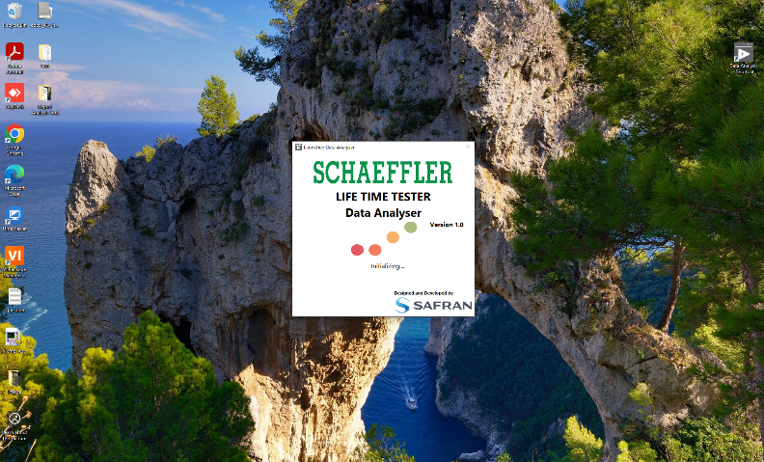
Figure 1: Lifetime Tester Data Analyser Splash Screen

User Interface Flow
The main screen of the Lifetime Tester provides the Report Analysis tool, allowing the user to access various software features of the system, such as data export and import, test information, error log, FE FF frame, signal plotting, and export. The software user interface flow is depicted in the schematic.
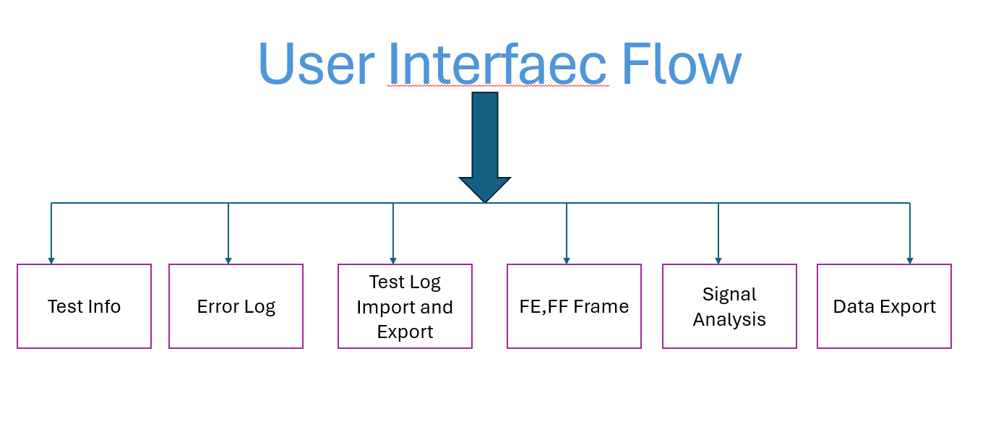
Figure 2: User Interface Flow

Main Screen
The main screen of the Report Analysis tool has the following buttons, as shown below. Only the Application Close, Test Log Import and Export button options are enabled.
- Select the Test Log button, if data is available, the options will be listed, referring to Section 6.
- If the Test Log button does not list any data, refer to Section 5.
- Option to select the Product.
- Option to select the Test Phase.
- Option to select the Test Name.
- Option to Refresh the Database Name List.
- Option to Delete the Listed Database Name.
- Option to select Frame Type (FE Frame and FF Frame).
- Option to select the Test Socket.
- Option to select the Test Mode.
- Option to set the Test Start and Stop Cycles.
- Option to Reset the Values for Test Sockets, Test Mode, Start Cycle, and Stop Cycles.

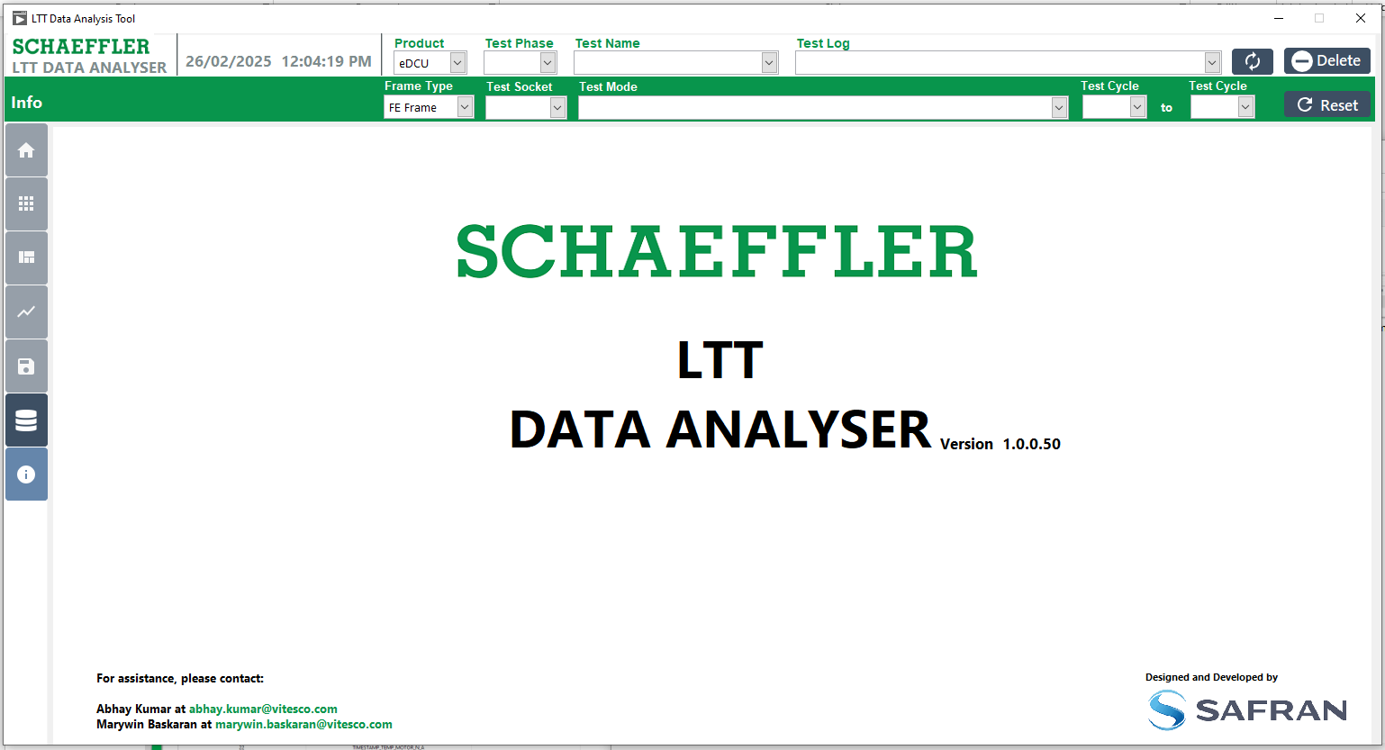
12
11
7
6
1&22
5
4
10
8
3
9

Figure 3: Main Screen

Test Log Import and Export Details
Clicking the 'Import and Export' button and its database symbol from the main window (Fig. 3) will open the window shown below (Fig. 4). Select the result folder and the respective fields for the files, then choose 'Import' or 'Export' to apply the changes. This module imports and exports data based on the selected schema and table files.

Procedure Test Log Import
- Click the "Import and Export" button to display the screen.
- To import the database, click the "Import" tab button.
- To export the database, click the "Export" tab button.
- The status of the import and export process will be updated with relevant messages.

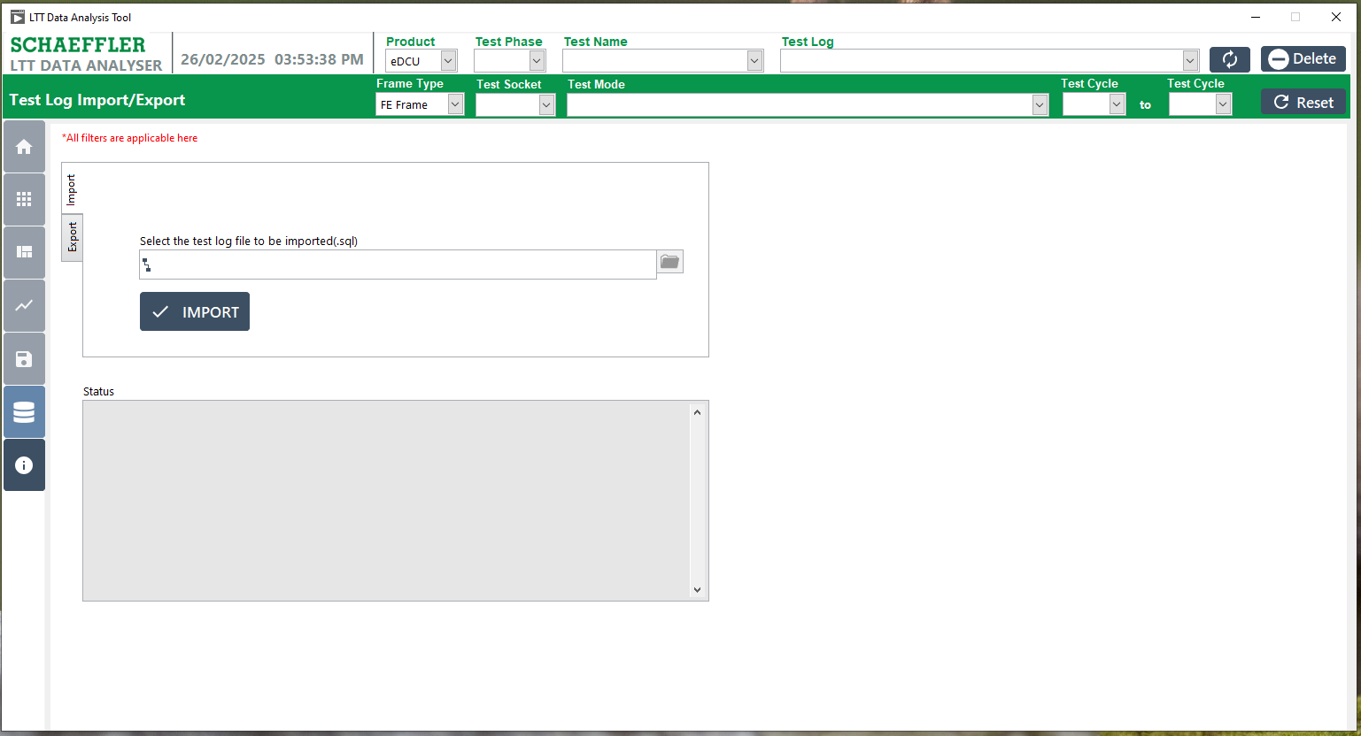
3
2
4
1
Figure 4: Import and Export Screen

Procedure the Test Log Import

  - Click the "Import" tab button.
  - Click the "Test Log File Import Database (.Sql)" to import the database.


2
1
Figure 5: Import Database File

Procedure for Import database file
- Select the respective path and choose the file (.Sql).
- The selected file name will be displayed.
- Click the "OK" or "Cancel" button to proceed.
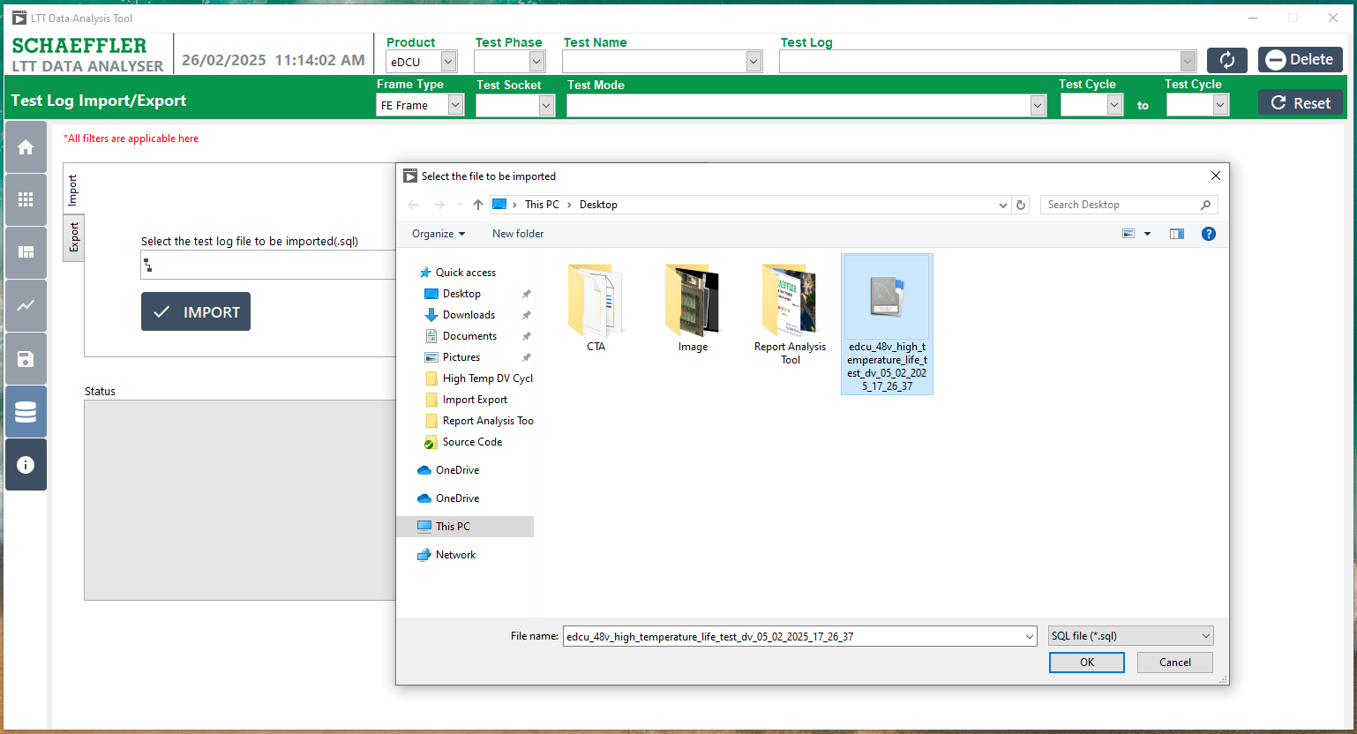
3
2
1
Figure 6: Import Data Selection

5.4 Procedure Import data File Loaded Show
- The selected file name will be displayed.
- Click the Import Button.
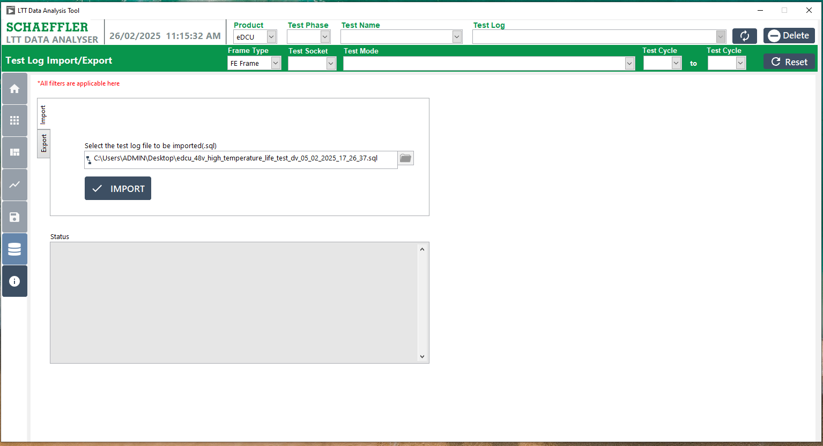
2
1
Figure 7: Import Data File Displayed.

Procedure to Import the File (In Progress).
- After clicking the "Import" button,
- The status for the import file will be displayed, showing the progress of the import process.
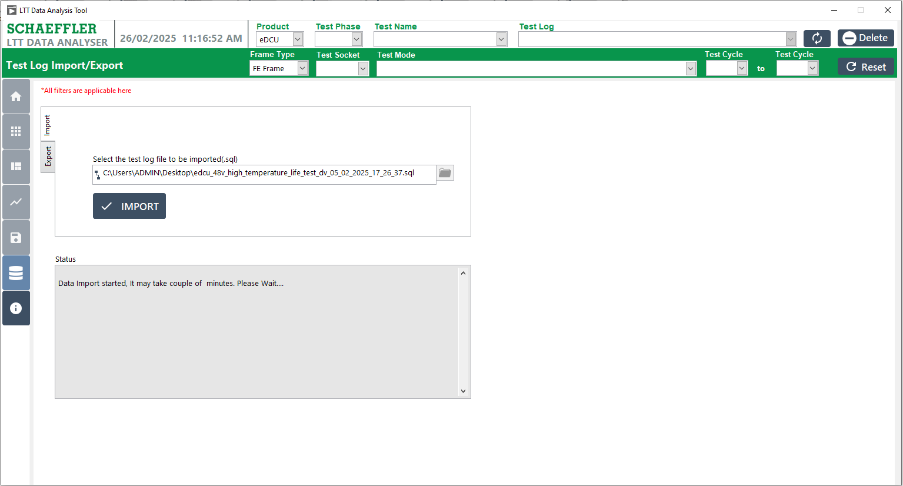
1
2
Figure 8: Import Data Inprograss

Procedure the Import Successful
- A pop-up will appear confirming that the import has been completed successfully.
- Click the "OK" button to acknowledge and close the pop-up.

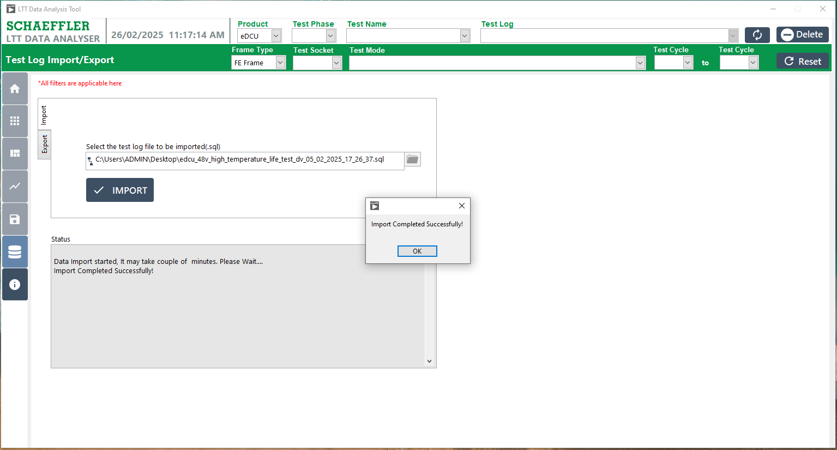
2
1
Figure 9: Import File Successful

Procedure the Import Database Succussfully Completed
- A message will appear confirming that the import status is completed, such as.

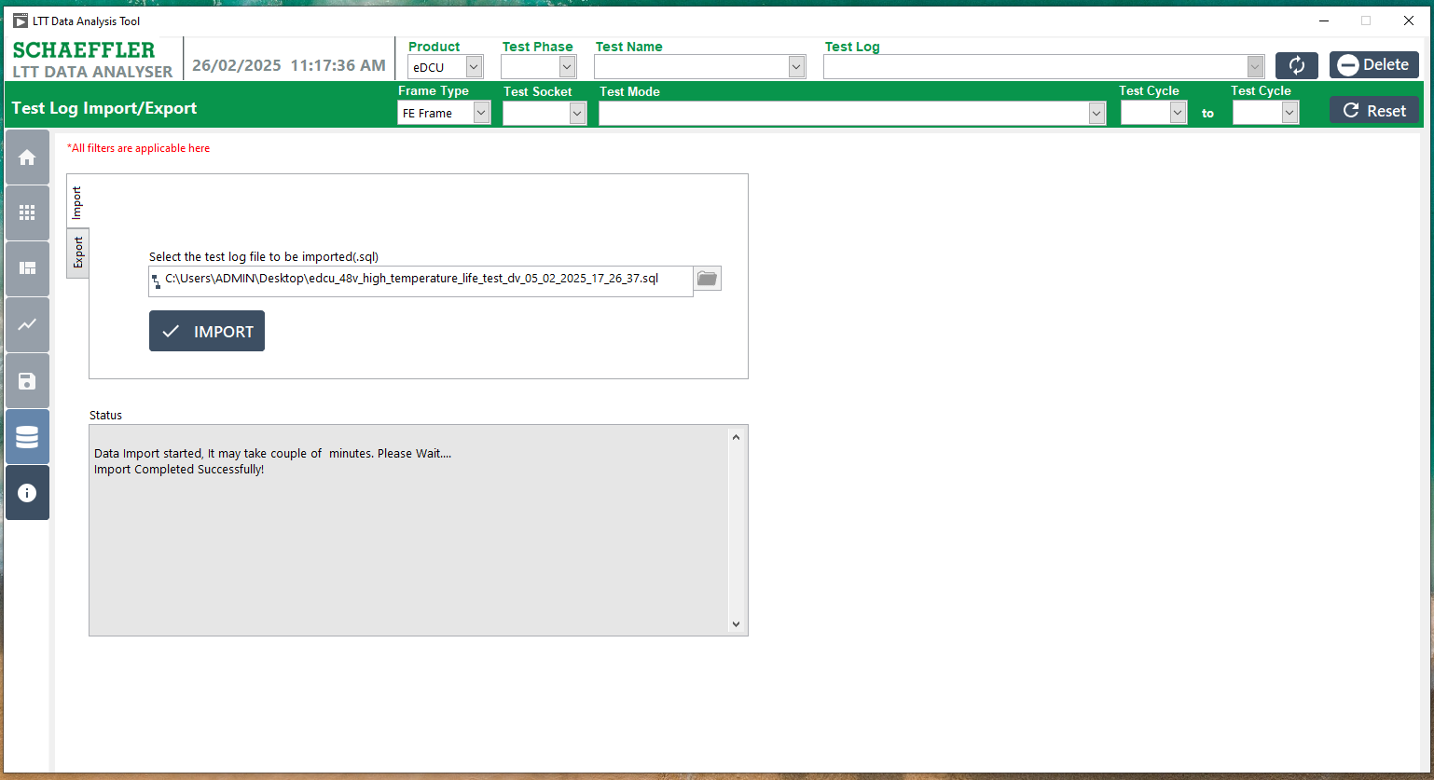
1

Figure 10: Import Status Show for successfully Completed

Procedure to Export the Database File.
- Click the "Import and Export" button to display the screen.
- To export the database, click the "Export" tab button.
- Select the Test Log Name from the available list.
- Select the export folder path where the file will be saved.
- After selecting the Test Log Name and the folder path, click the "Export" button to complete the export process.
- The status of the import and export process will be updated with relevant messages.
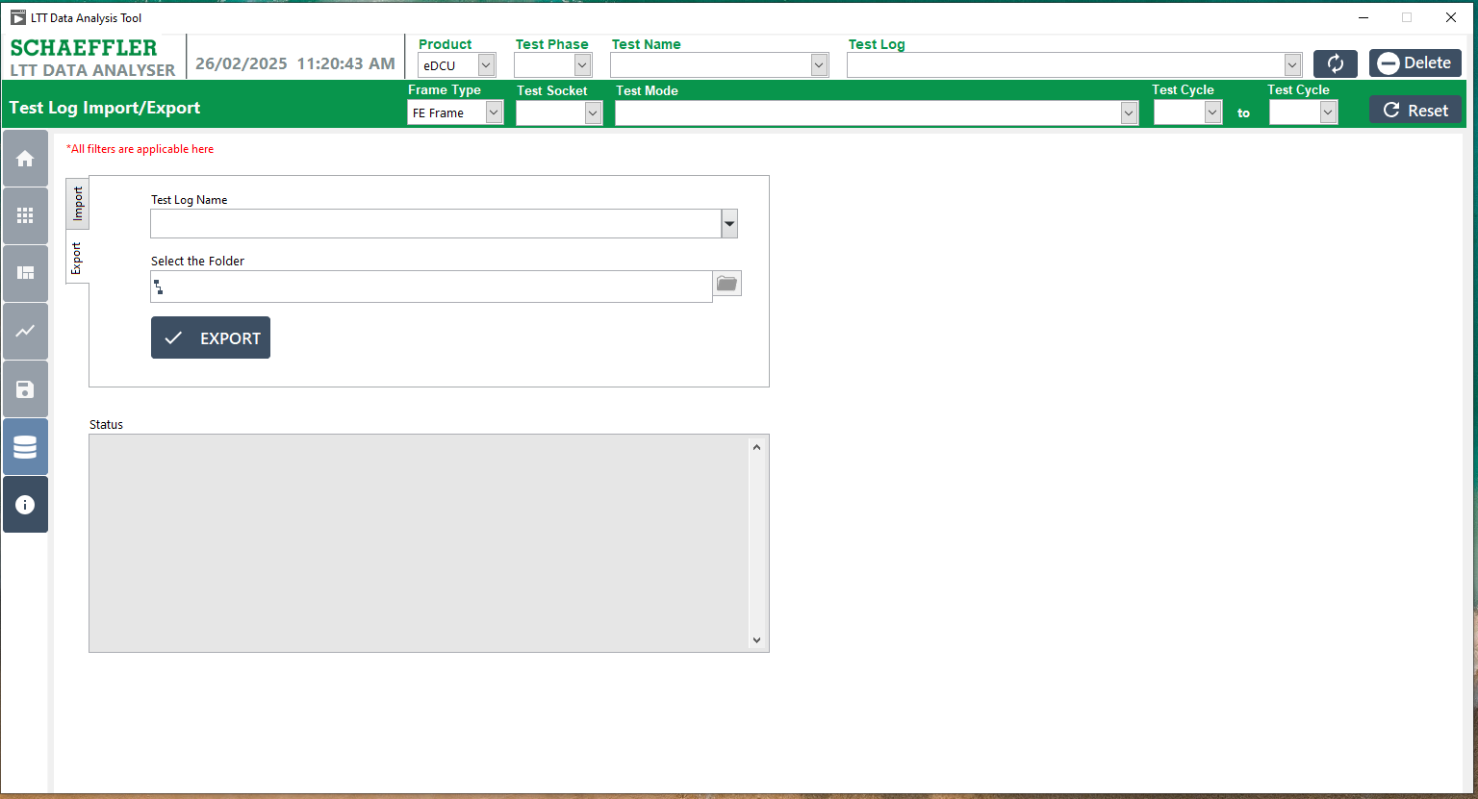
5
4
3
2
1
6
Figure 11: Export the Database File

Procedure to Export the Folder Selection
- Select the respective folder path where you want to export the file.
- Click the "Select Folder" button to confirm the selected folder and proceed with the export.
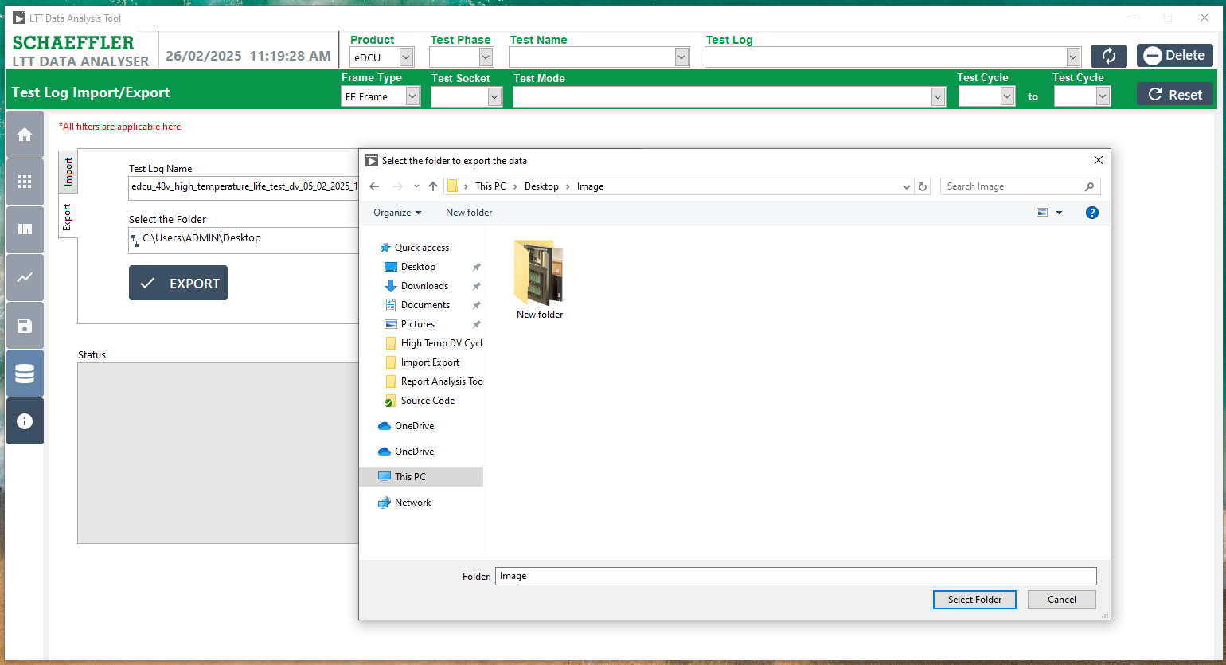
1
2

Figure 12: Export Database File Folder Selection

Procedure for Exporting the Selected Database File and Displaying.
- The selected file name will be displayed in the Test Log Name field.
- The selected folder name will be displayed in the Export Folder field.
- Click the Export button to start the export process.
- The Export Status will be shown, indicating the progress of the exports.
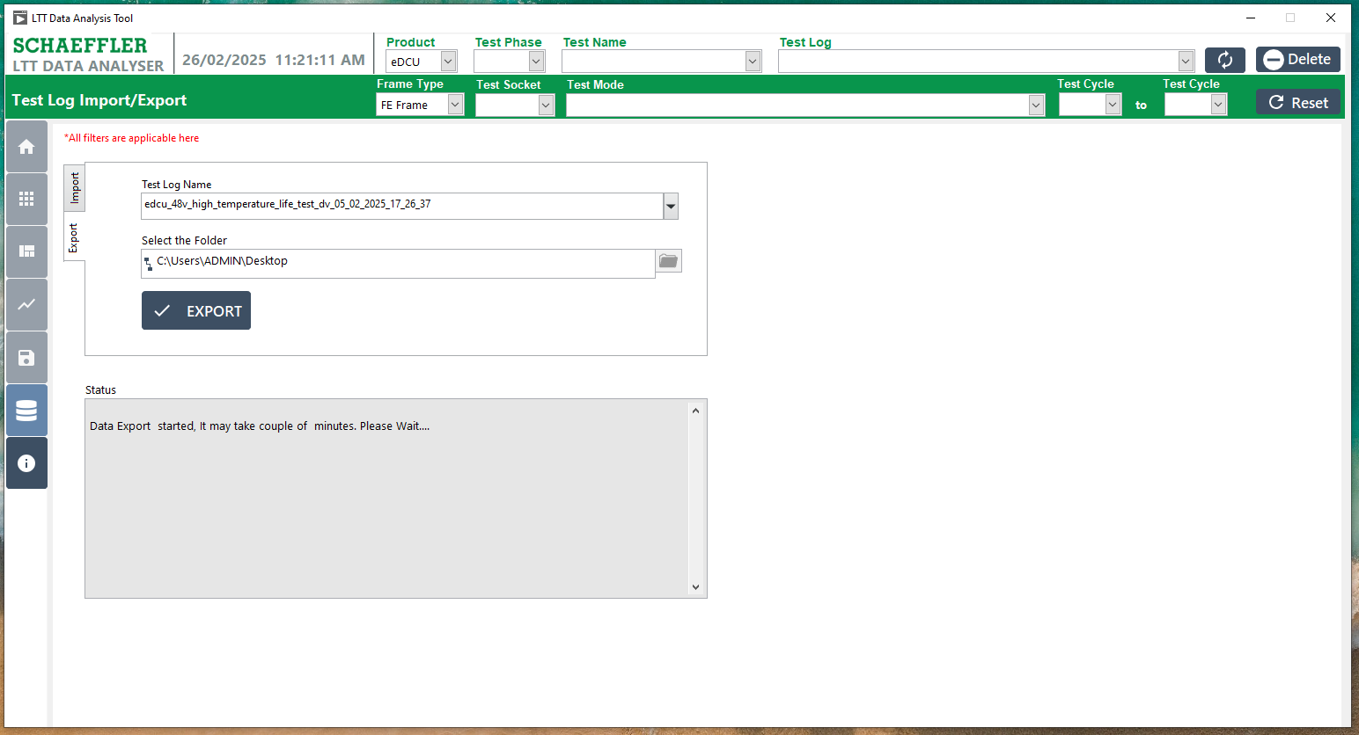
4
3
2
1
Figure 13: Export of the Selected Database File Displayed.

Procedure for Export Database File Successfully Completed.
- A message will appear confirming that the import status is completed, such as.
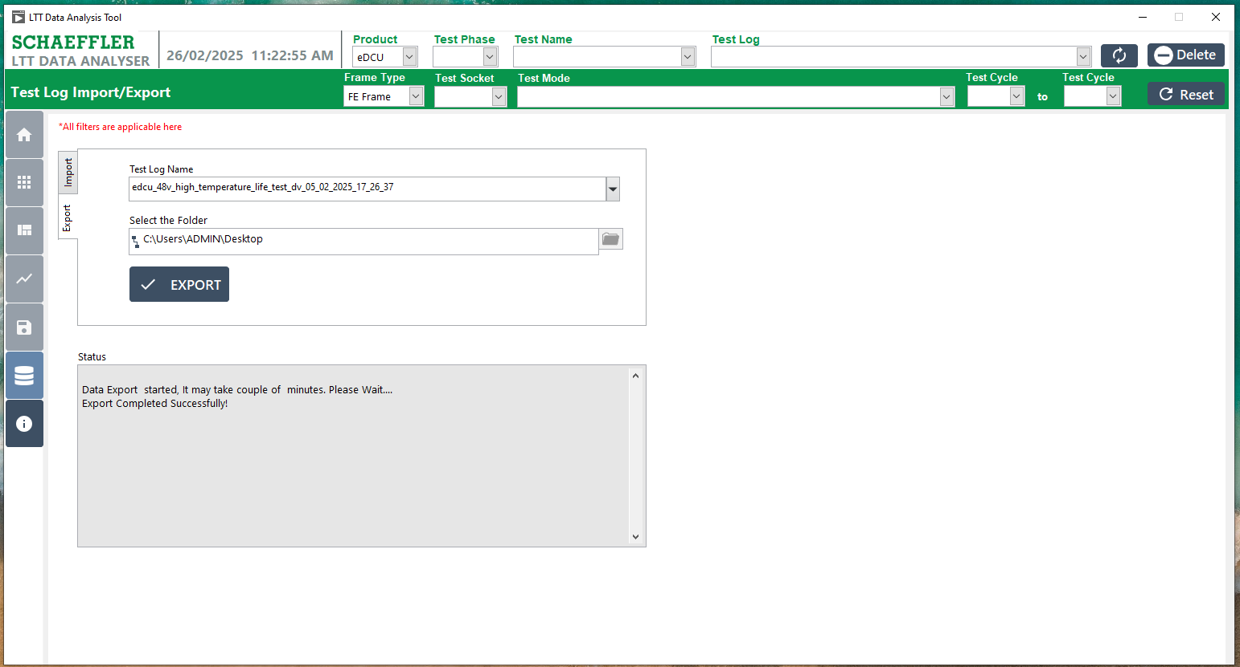
1
Figure 14: Export the Database file Successfully Completed.

Test Log Selection

6.1 Selected the Test Log Name
- Select the Test Log Name, and once selected, enable all control buttons on the screen to allow full functionality.
- Once the Test Log Name is selected, all control buttons will be enabled, allowing access to the following options.
      - Test Log Import and Export
      - Test Info
      - Error Log
      - FE FF Frame
      - Plot Signals
      - Export

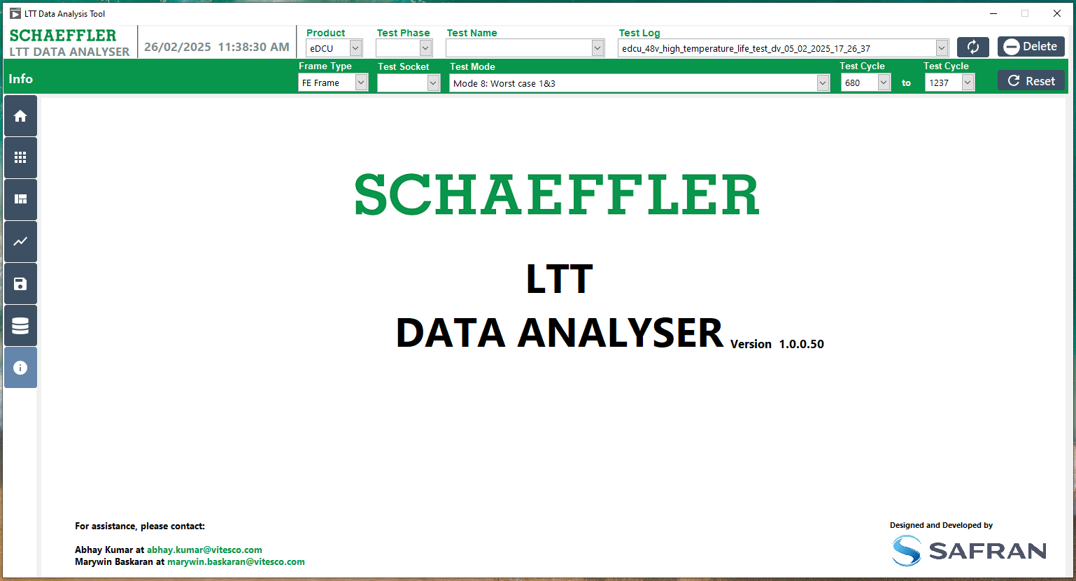
1 showing Popup
2 showing Popup

Figure 15: Test Log Selected

Test Information

7.1 Test Info View:
- Click the "Test Info" button, which is represented by the Home Symbol.
- The screen will display the following Date and Time details:
      - Test Start Date
      - Estimated Completion Date
      - Remaining Time
      - Completed Time
- The screen will show the Cycles and Percent details:
      - Total Cycles
      - Cycles Completed
      - Remaining Cycles
      - Completed Percentage
- Test information data will be displayed, including the above details, providing an overview of the test's progress and status.
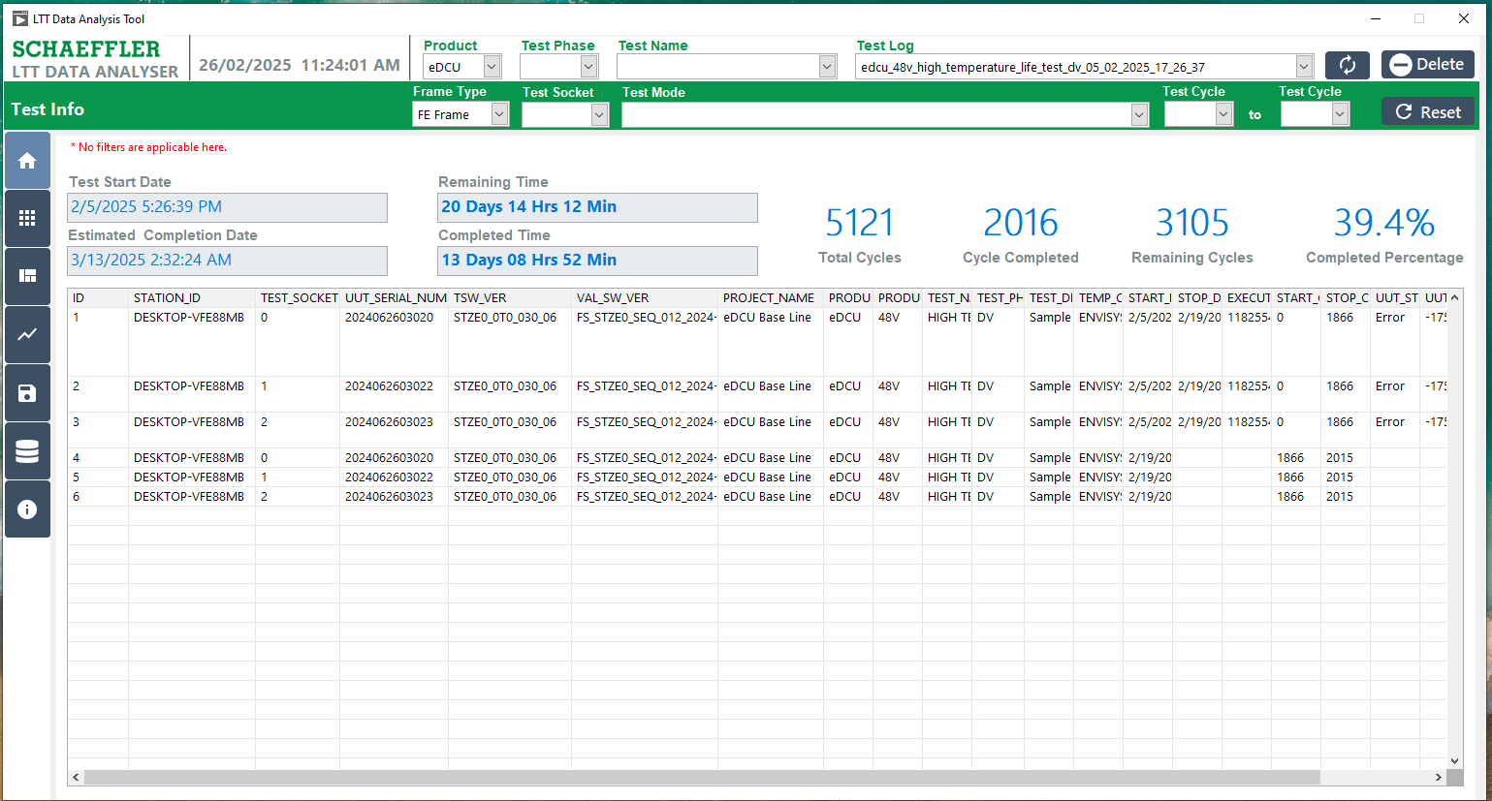
2 showing Popup
4 showing Popup
3 showing Popup
1 showing Popup
Figure 16: Test Information View

Errors Log

Procedure for Error Log:
- Click the "Error Log" button, represented by the Dial Symbol.
- The Test Log has already been selected, and the Errors List Table is updated to show the Socket, Error Signal, and Error Count for each specified Socket.
- The Error Log filter is applied for both the Start Test Cycle and Stop Test Cycle.
- Click "Refresh Data" to display the error data.
- The specified errors will be displayed accordingly.

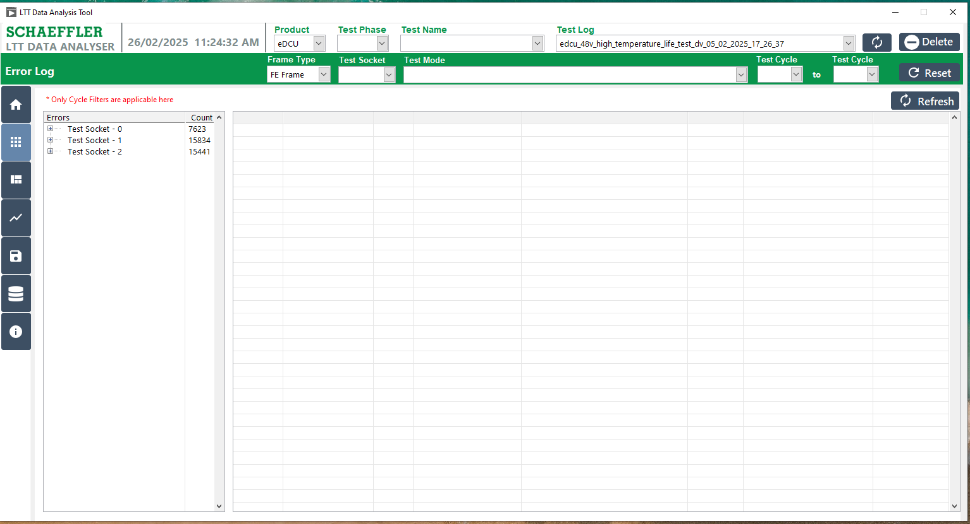
4
3
5
2
1
Figure 17: Procedure for Error Log

Procedure for Error Log – Test Socket Signal Select.
- Click on the Test Socket to list the associated Error Signals.
- Display the Error Signals.
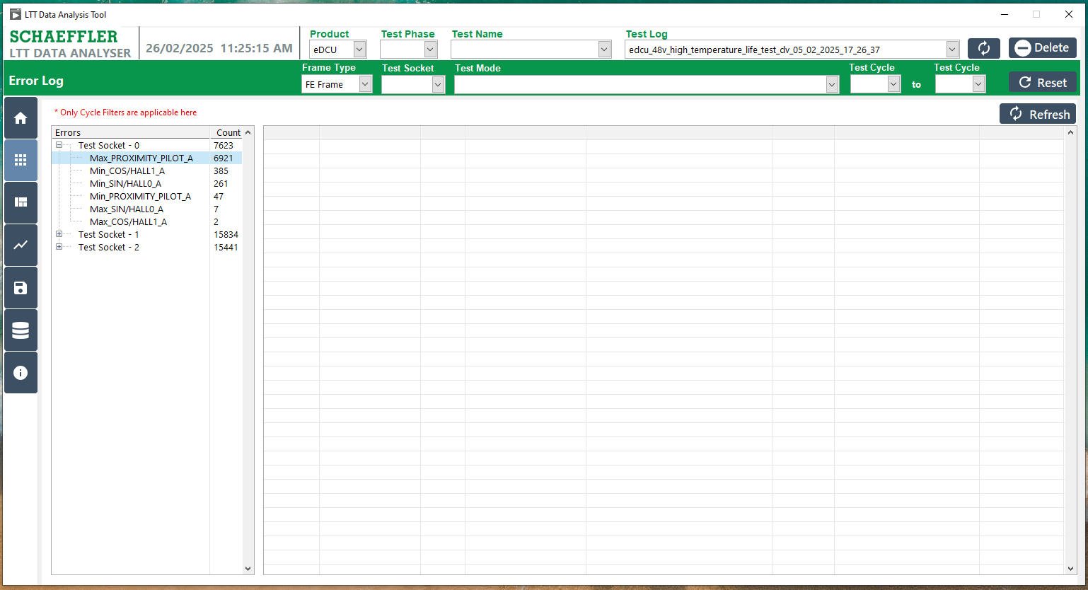
1
2
Figure 18: Error Log – Test Socket and Signal Listed

Procedure for Error Log – Signal Selected and View Data
- Click the Selected Signal and Show the Error Count specify signal.
- Selected Signal data Showing the Displayed.
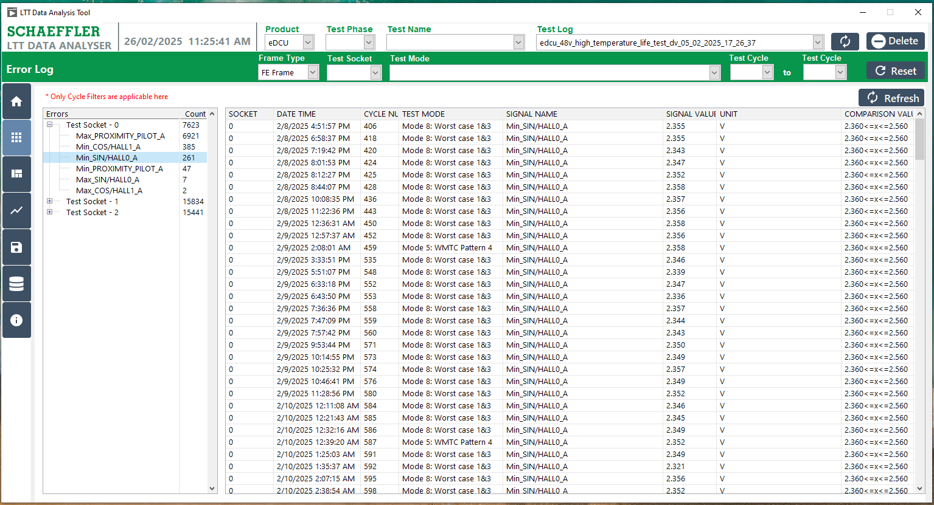
2
1
Figure 19: Error Log Selected Signal and View Data

Procedure for Error Log – Selected the Mode based Data View.
- Select the Test Mode.
- Click the Refresh Button.
- Choose the Error List from the Signals and Count.
- Display the selected Test Mode and Signal.
4
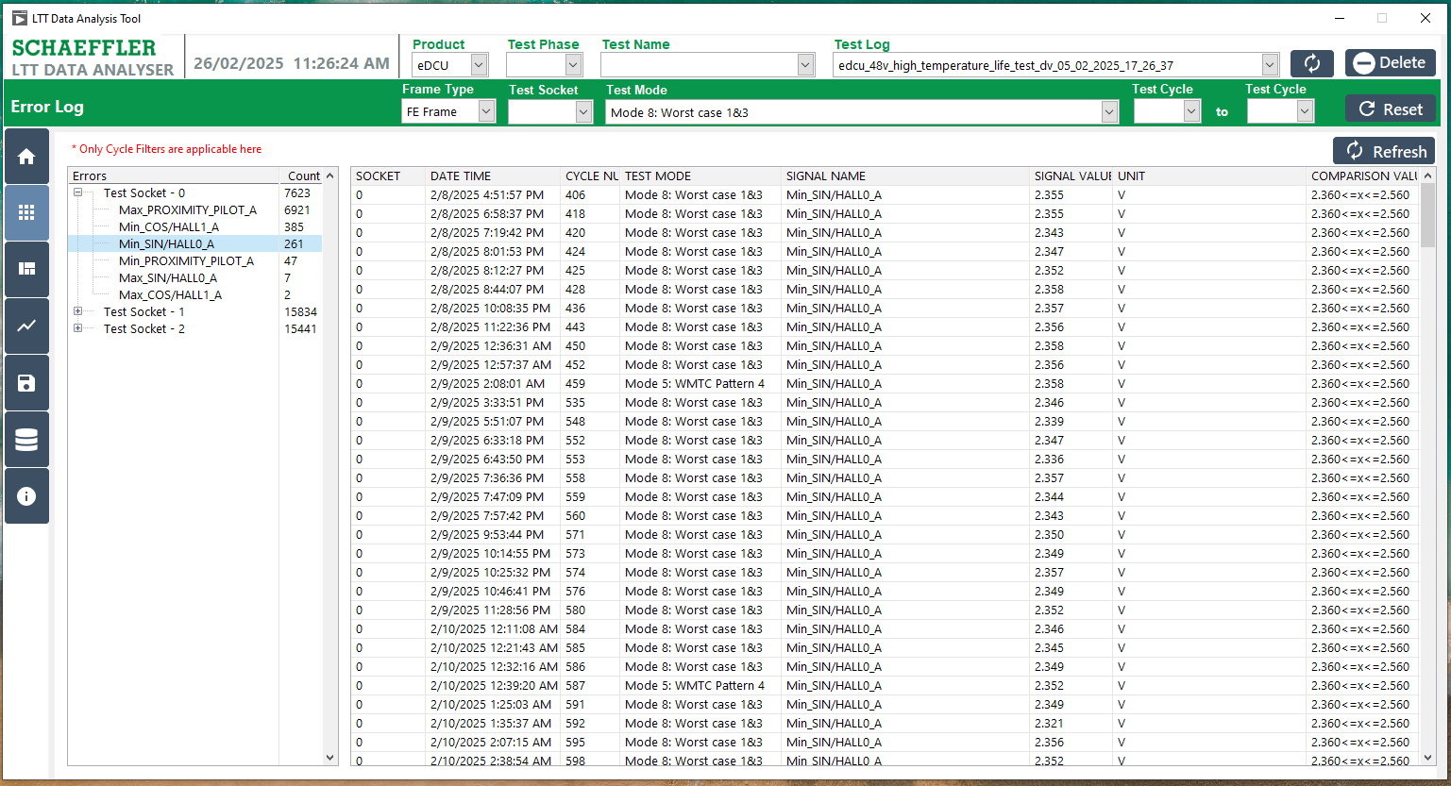
3
2
1
Figure 20: Error Log Selected Mode and Data View

Procedure for Error Log- Selected the Cycle Number based View Data:
- Select either the Start Cycle or Stop Cycle to list the errors.
- Click the Refresh Button.
- Choose the Error List from the Signals and Count.
- Display the selected either the Start Cycle or Stop Cycle and Signal.
4
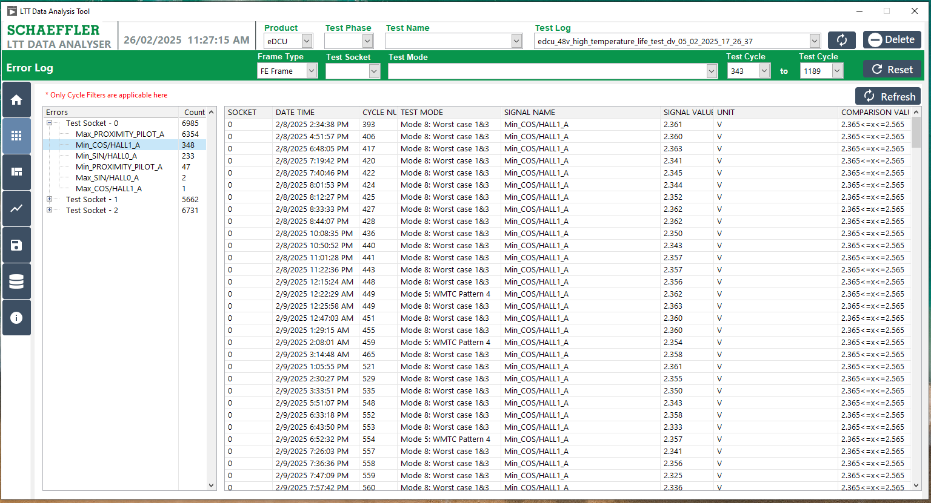
2
2
1
Figure 21: Error Log – Selected Cycle and Data View

Procedure for Error Log – Specifly Signal Selected and View the FE and FF Frames.
- Double-click the specific signal listed in the data.
- Display the selected signal based on the FE and FF frames.
4
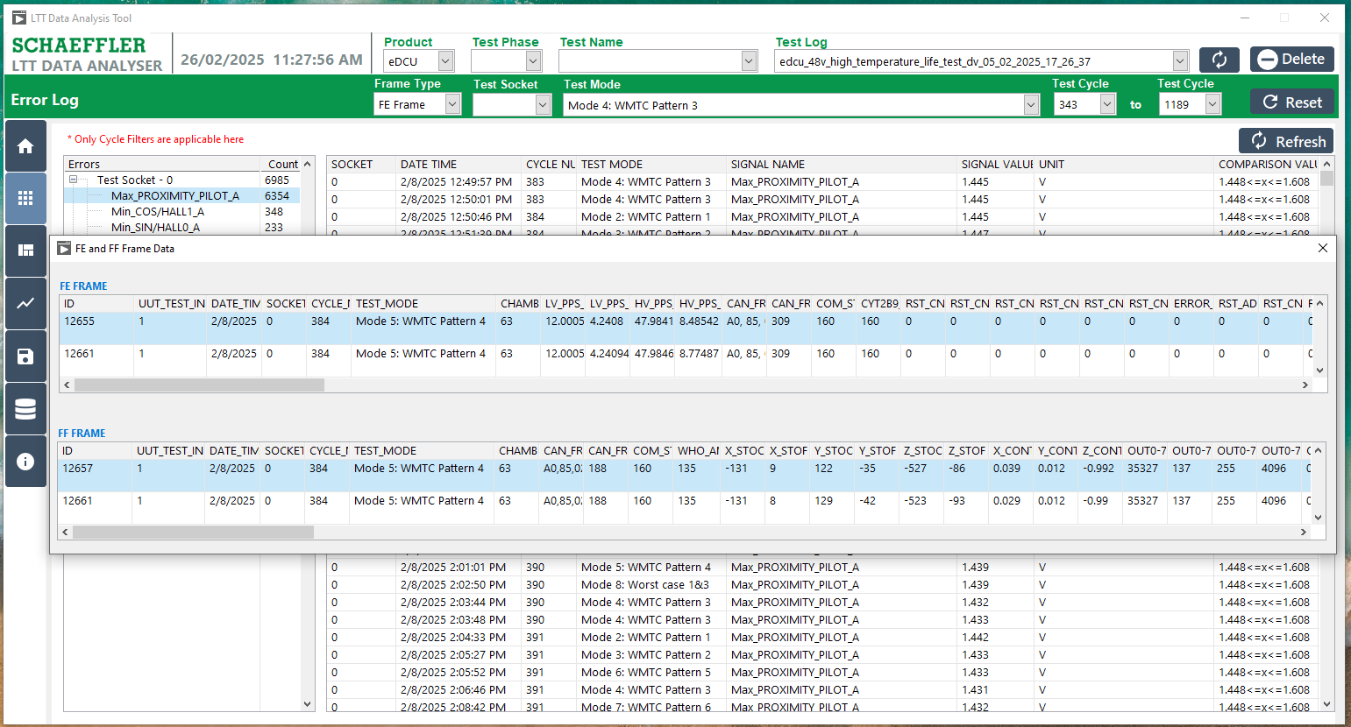
2
1
Figure 22: Error Log – Display FE and FF frames

FE and FF frames

Procedure for FE and FF Frame
- Click the "FE / FF Frames " button, represented by the Settings Symbol.
- The Test Log has already been selected, and the available filter options include Frame Type, Test Sockets, Test Mode, and Test Start or Stop Cycles.
- Option to apply all data.
- Option to view data by date.
- Option to choose file format (.csv, .xlsx).
- Option to export and save data.
- Display the data after applying the filter.
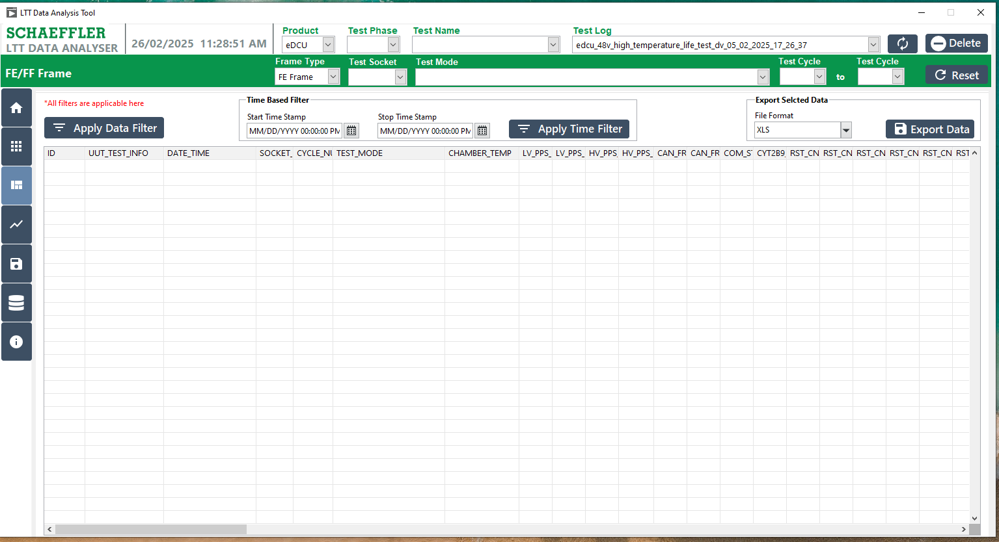
2
7
5
6
4
3
1
Figure 23: FE and FF Frames

Procedure for FE and FF Frame – Apply the Data Filter.
- Click the 'Apply Data Filter' button.
- Display all the data.
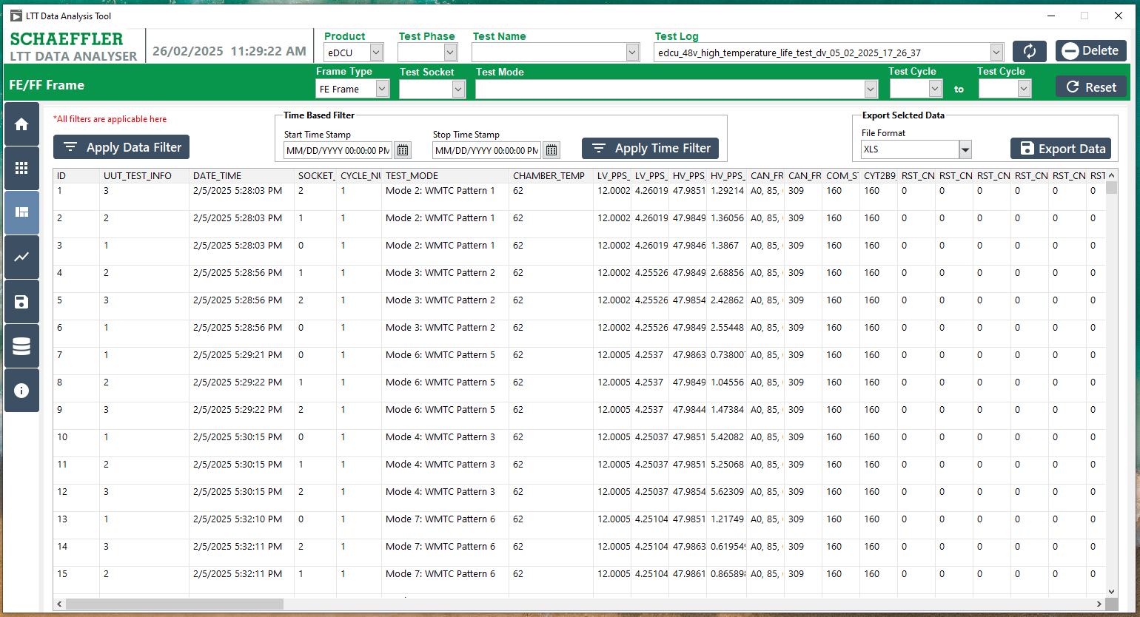
2
1
Figure 24: FE and FF Frames All Data Filter

Procedure for FE and FF Frame - Apply the Time stamp Filter:

- Select the Start and Stop Time, then fill in the Date and Time to filter the data.
- Click the "Apply Time Filter" button.
- Display all the data based on the Timestamp filter.
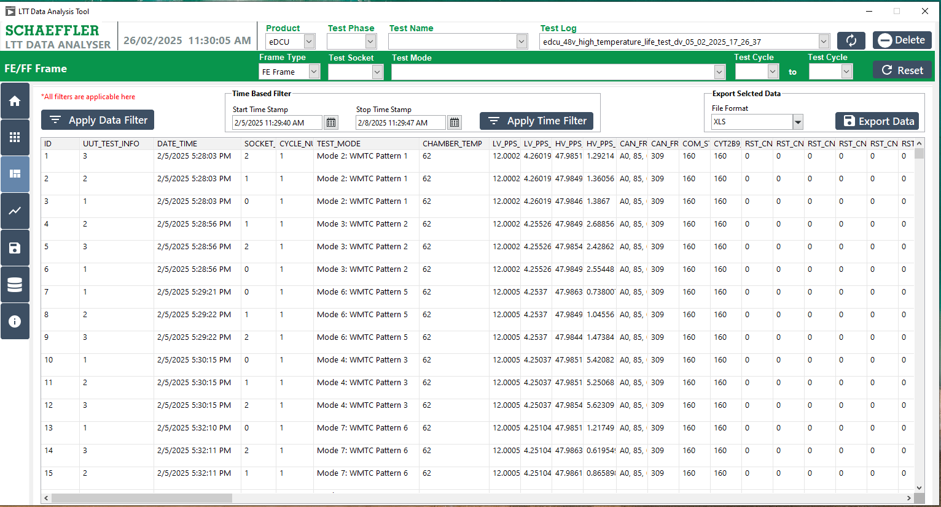
2
1
3
Figure 25: FE and FF Frame Date and Time Filter

9.4 Procedure FE and FF Frame- Selected the Frame:
- Select the Frame Type as either FE Frame or FF Frame.
- Click either the "Apply Time Filter" or "Apply Frame Filter" button.
- Display all the data based on the selected FE or FF Frame filter.

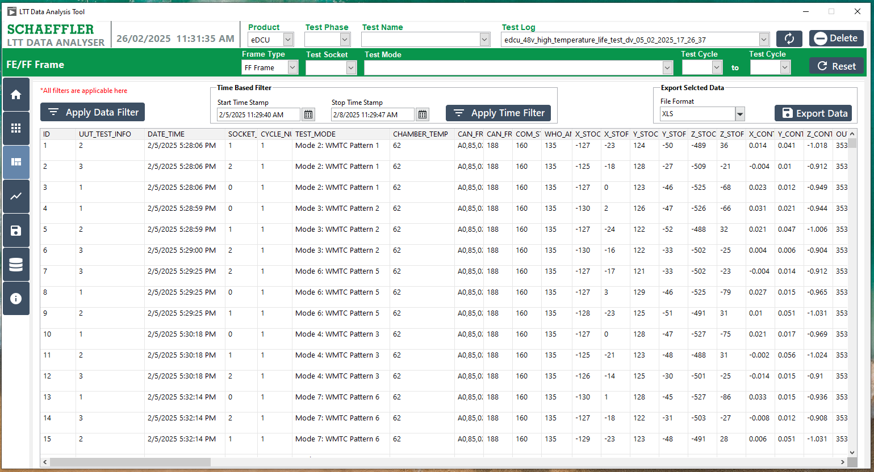
3
2
1
Figure 26: FE and FF Frame Selection Filter

9.5 Proceed for FE and FF Frame- Selected Mode:
- Select the Frame Type as either FE Frame or FF Frame and choose the Test Mode.
- Click either the "Apply Time Filter" or "Apply Frame Filter" button.
- Display all the data based on the selected FE or FF Frame filter and Test Modes.
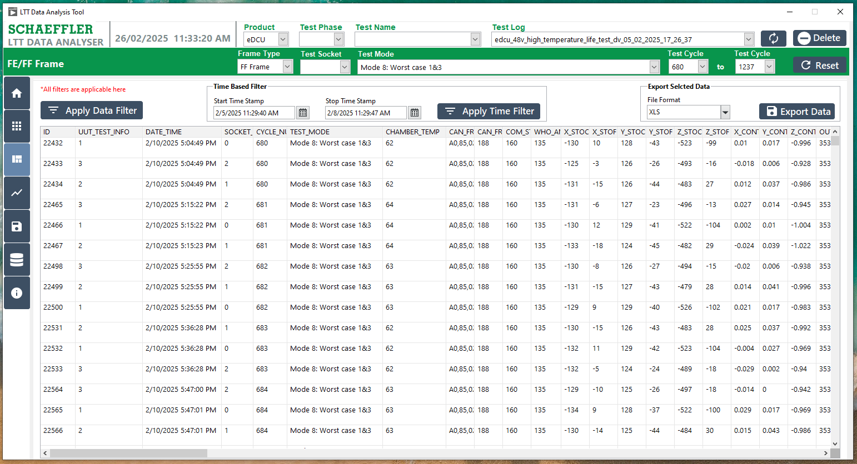
1
1
2
2
3

Figure 27: FE and FF Frame and Test mode Filters

9.6 Procedure for FE and FF Frame – Selected the Export Data:
- Click either the "Apply Time Filter" or "Apply Frame Filter" button.
- Display all the data based on the selected FE or FF Frame filter.
- Select the desired file format (.xlsx or .csv).
- Click the "Export" button.
- Choose a folder and click the "Select Folder" button.
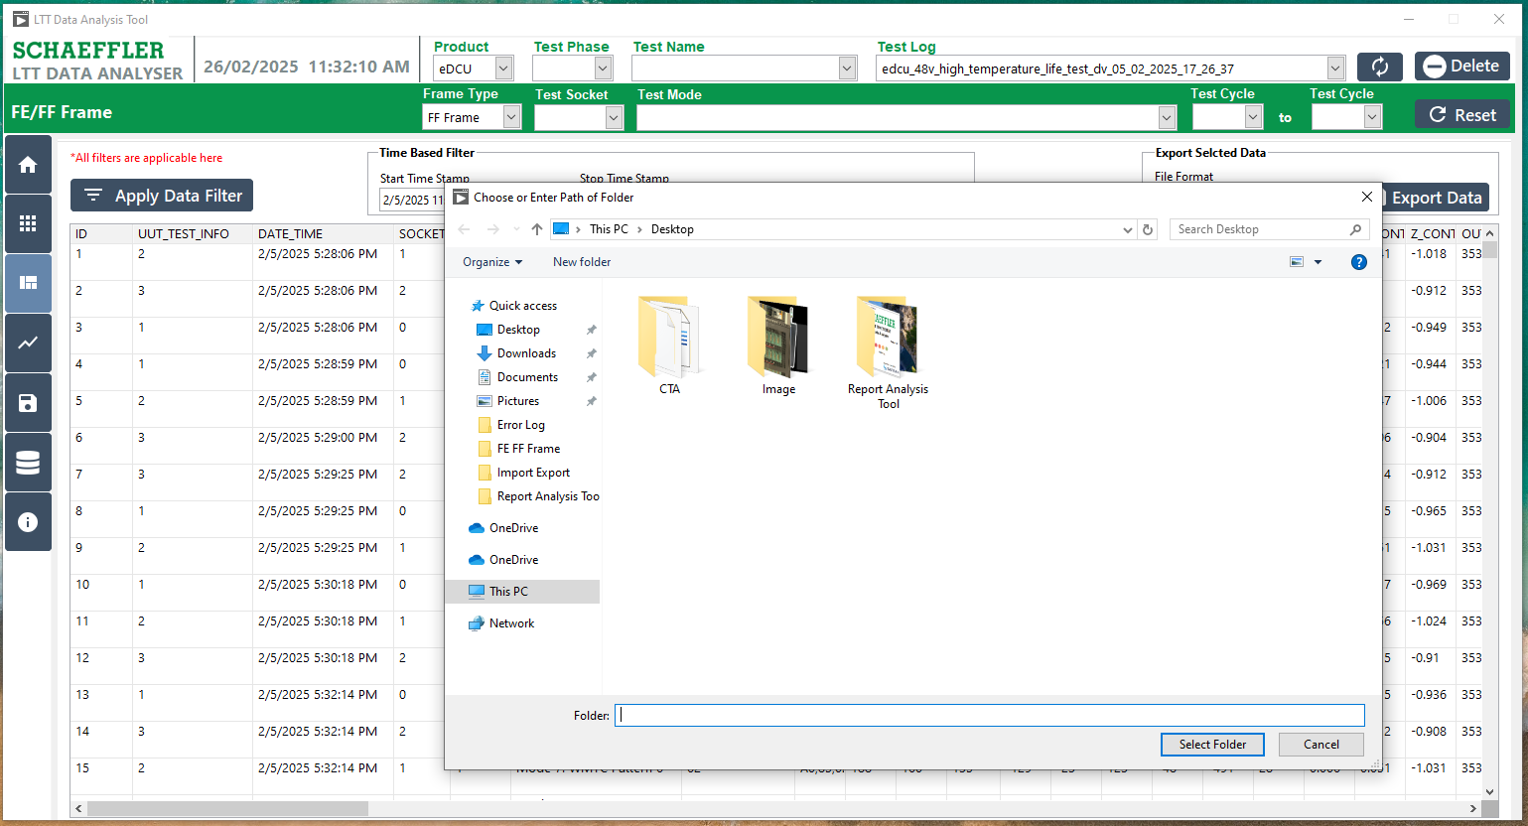
5
1 showing Popup
2 showing Popup
4
3 showing Popup

Figure 28: FE and FF Frame Export Data

Plot Signals

10.1 Procedure for Plot Signals:
- Selected the Test Log
- Click the "Plot Signals" button, represented by the Graph Symbol.
- The Test Log has already been selected, This filter is Mandatory Frame Type, Test Mode and the available filter options include Test Sockets, and Test Start or Stop Cycles.
- Select the Signal Name and click the "Apply Plot Signal" button.
- The respective signal graph will be displayed.
- Alternatively, select another Signal Name and click the "Apply Plot Signal" button.
- The respective signal graph for the second signal will be displayed.
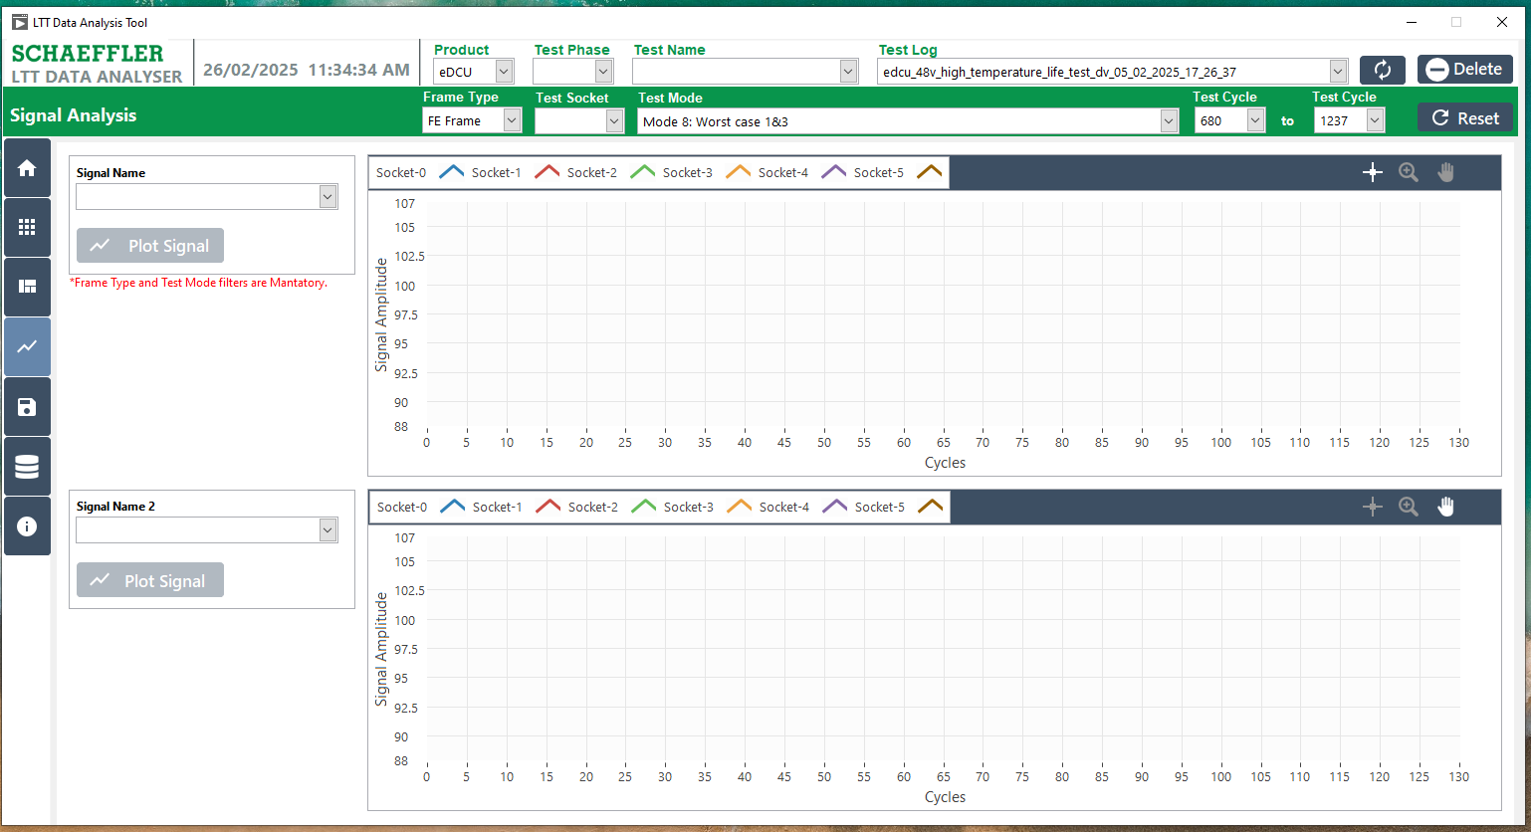
3 showing Popup
4 showing Popup
6 showing Popup
7 showing Popup
5 showing Popup
1 showing Popup
2 showing Popup

Figure 29: Procedure for Plot Signals

10.2 Procedure for Validation of the Signals:
- The Test Log has already been selected, this filter is Mandatory Frame Type, Test Mode and the available filter options include Test Sockets, and Test Start or Stop Cycles.
- Select the Signal Name and click the "Apply Plot Signal" button.
- The respective signal graph will be displayed.
- Alternatively, select another Signal Name and click the "Apply Plot Signal" button.
- The respective signal graph for the second signal will be displayed.

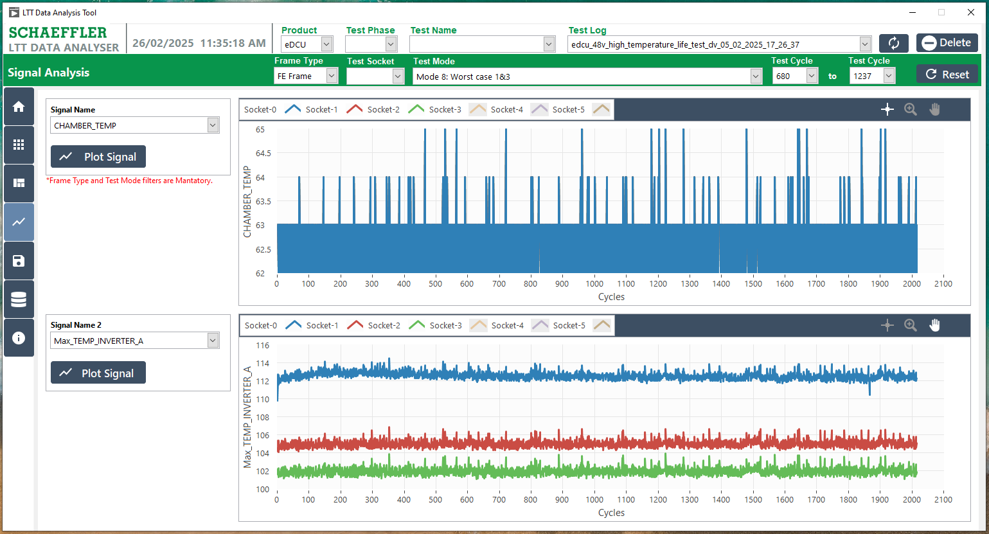
5 showing Popup
4 showing Popup
3 showing Popup
2 showing Popup
1 showing Popup

Figure 30: Plot Signals - Validation

Export Data

11.1 Procedure the Export the Data:
- Selected the Test Log
- Click the "Export Data" button, represented by the File Symbol.
- Select the table name.
- The data for the selected table will be displayed.
- Choose the desired file format (.xlsx or .csv).
- Export the data in the selected file format.

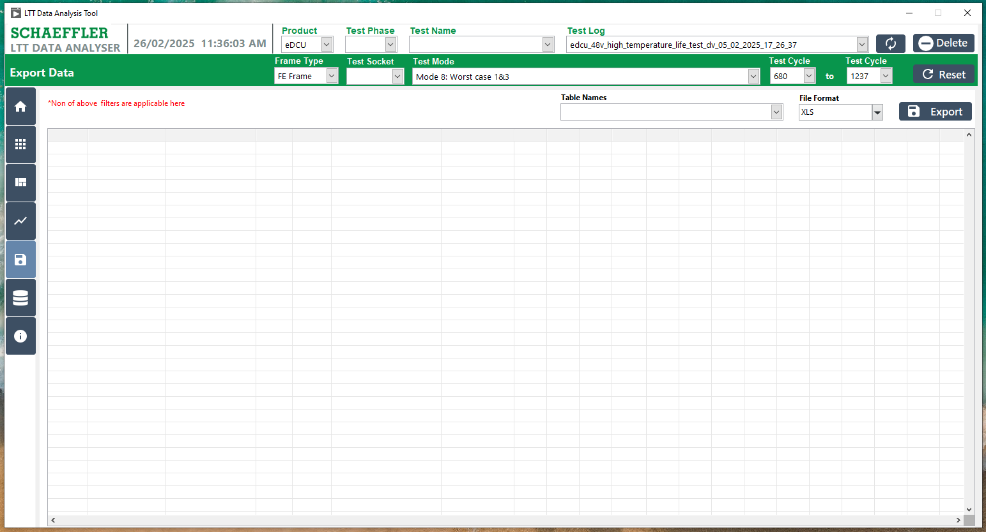
6 showing Popup
5 showing Popup
4 showing Popup
3 showing Popup
2 showing Popup
1 Popup

Figure 31: Procedure the Export Data

11.2 Procedure for Select the Table and Show Data:
- Select the table name.
- The data for the selected table will be displayed.
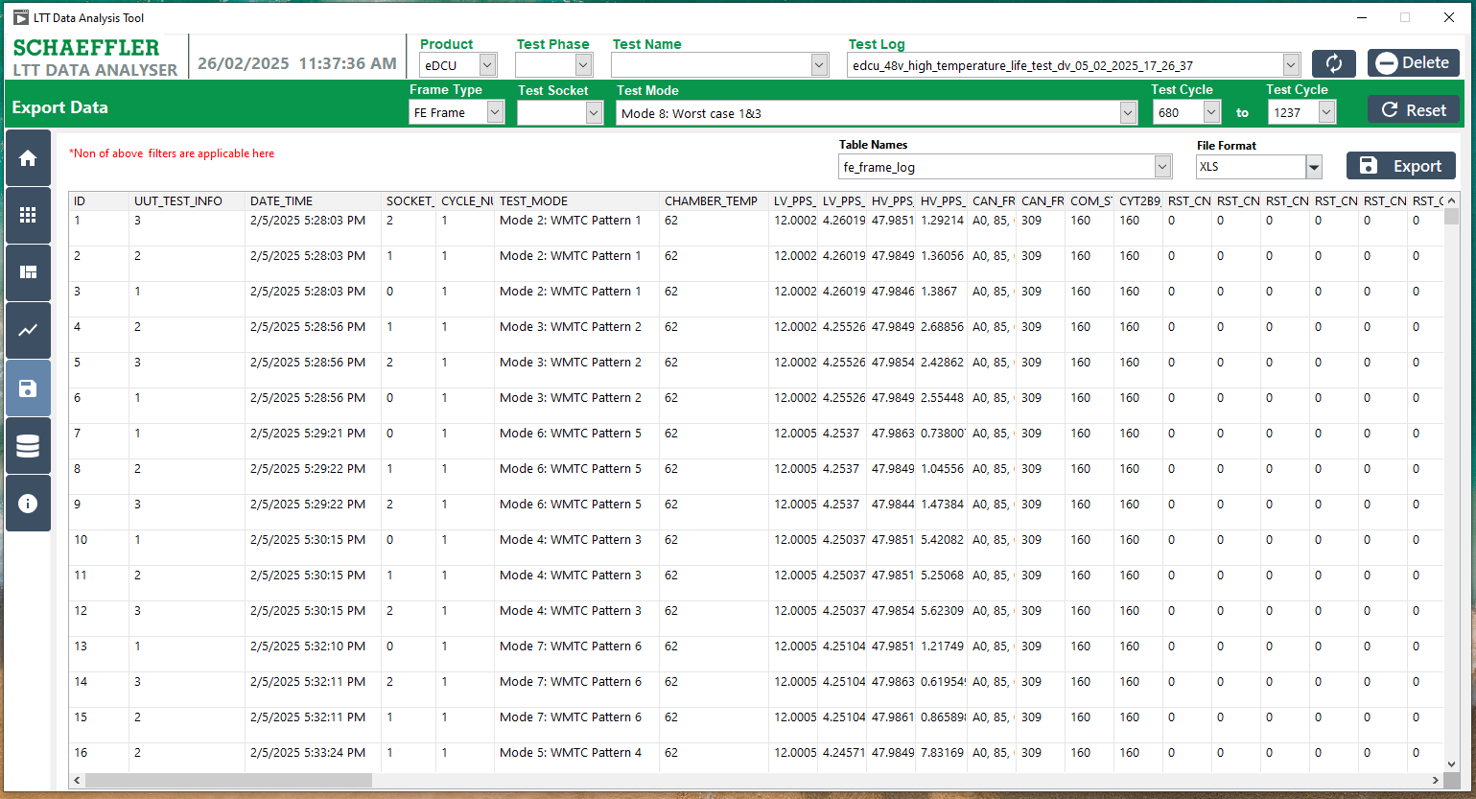
2 showing Popup
1 showing Popup

Figure 32: Export Data – Selected Table and Show Data.

11.3 Procedure for Export Data- Export Save as File:
- Select the table name.
- The data for the selected table will be displayed.
- Choose the desired file format (.xlsx or .csv).
- Export the data in the selected file format.
- Choose a folder and click the "Select Folder" button.

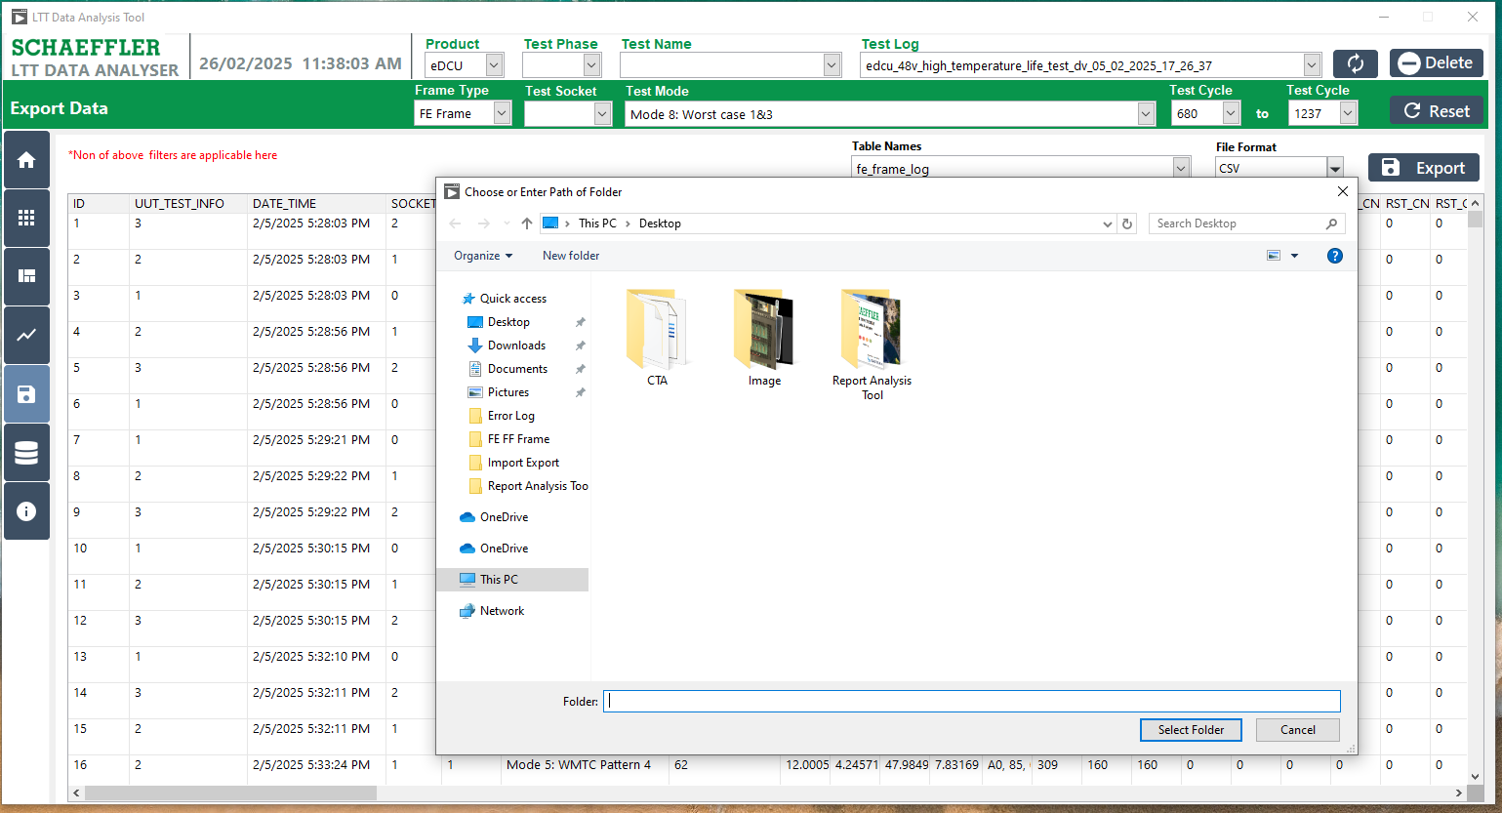
5
4 showing Popup
3 showing Popup
2 showing Popup
1 showing Popup

Figure 33: Export Data as File Format

